80. Lightning Event Handling, Application Event – 01 August 2022

Aura Lightning Event Handling



**Event**

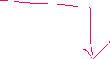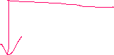

System Event

Component Event

Application Event

**1] Application Event:**

Component B

Component A

Definition : Application Event is used to communicate two **Independent** Components.

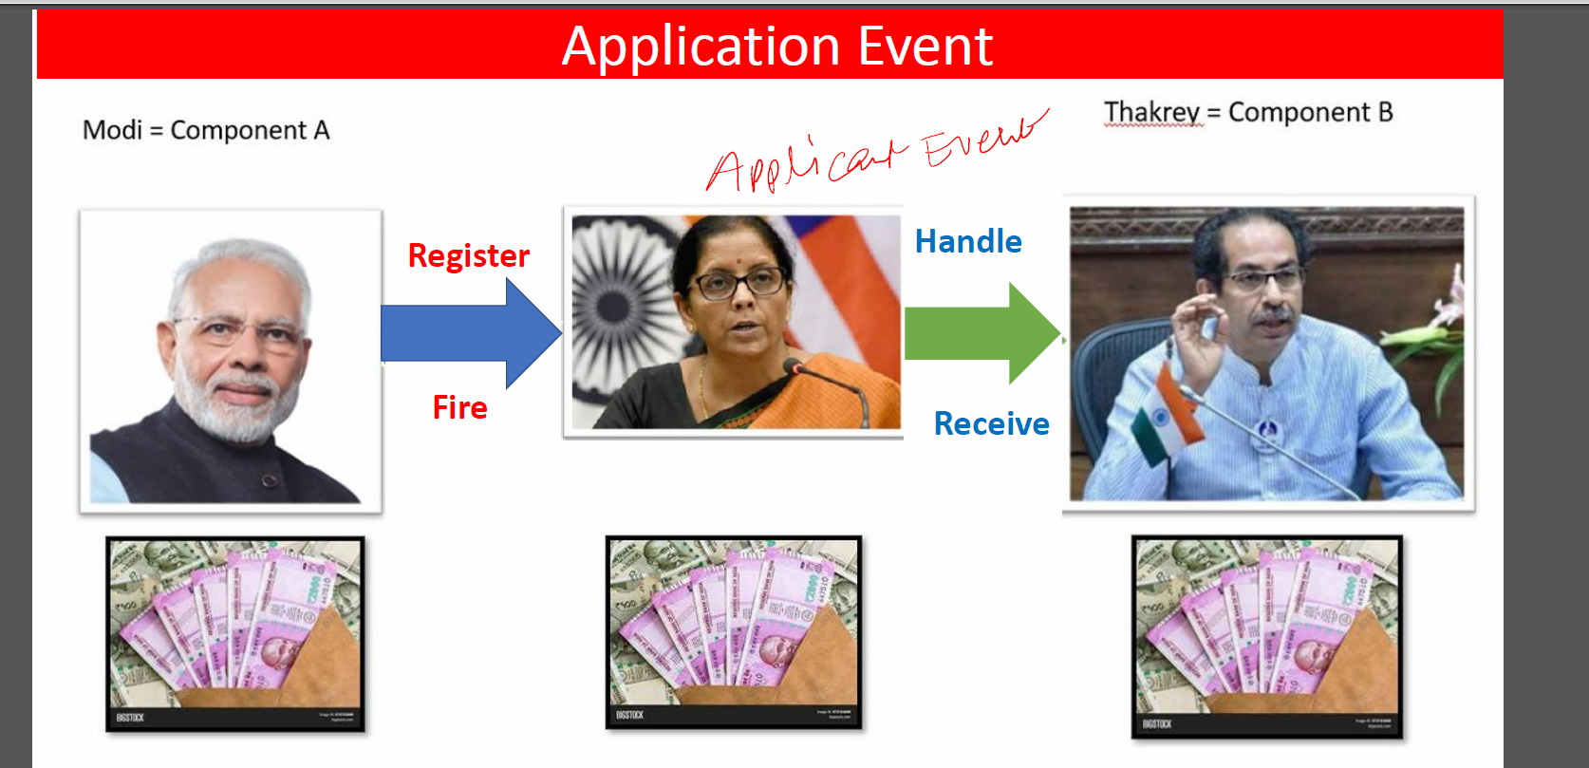

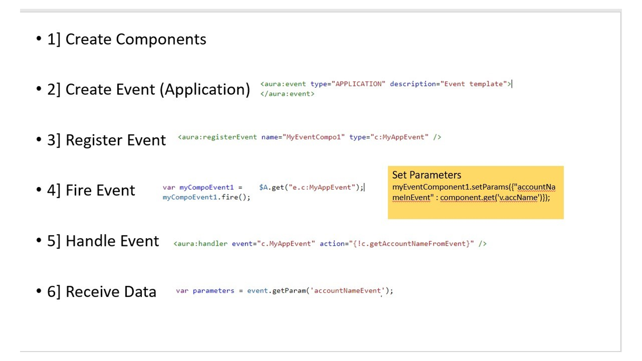



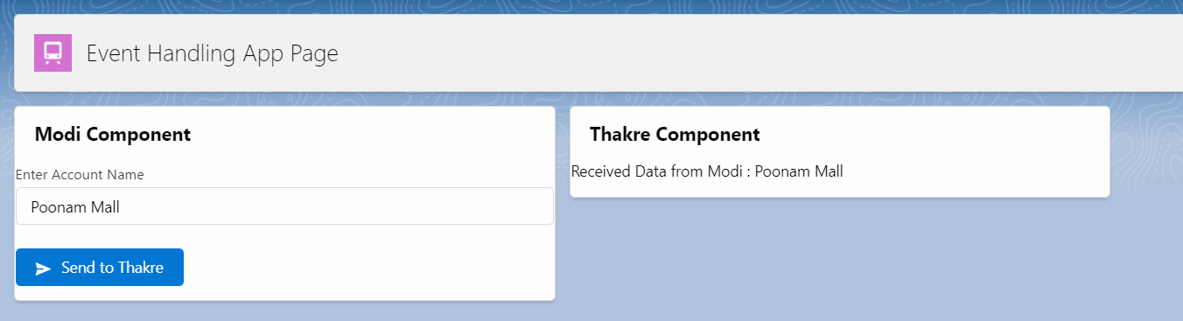

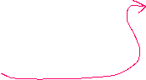

EVENT :

<aura:event type="APPLICATION" description="Event template">

<aura:attribute name="sitaramEventAccName" type="String"/>

</aura:event>

Modi Component:

<aura:component implements="force:appHostable,flexipage:availableForAllPageTypes,flexipage:availableForRecordHome,force:hasRecordId,forceCommunity:availableForAllPageTypes,force:lightningQuickAction" access="global" >

<aura:attribute name="accountName" type="String" />

<aura:registerEvent name="SitaramanEventRegistration" type="c:SitaramEvent" />

<lightning:card title="Modi Component">

<lightning:input type="text" label="Enter Account Name" value="{!v.accountName}" /> <br/>

<lightning:button variant="brand" iconName="utility:send" label="Send to Thakre" onclick="{!c.sendToThakreController}" />

</lightning:card>

</aura:component>

JS Controller:

({

sendToThakreController : function(component, event, helper) {

var applicationEvent = $A.get("e.c:SitaramEvent");

applicationEvent.setParams({"sitaramEventAccName" : component.get('v.accountName')});

applicationEvent.fire();

}

})

Thakre Component:

<aura:component implements="force:appHostable,flexipage:availableForAllPageTypes,flexipage:availableForRecordHome,force:hasRecordId,forceCommunity:availableForAllPageTypes,force:lightningQuickAction" access="global" >

<aura:attribute name="receivedFromModi" type="String" default="Waiting......!!" />

<aura:handler event="c.SitaramEvent" action="{!c.receiveDataController}" />

<lightning:card title="Thakre Compo">

Received Data from Modi = <ui:outputText value="{!v.receivedFromModi}" />

</lightning:card>

</aura:component>

JS Controller:

({

receiveDataController : function(component, event, helper) {

var receivedData = event.getParam("sitaramEventAccName");

console.log('Zatka Laga...!!!!! '+receivedData);

component.set('v.receivedFromModi',receivedData);

}

})

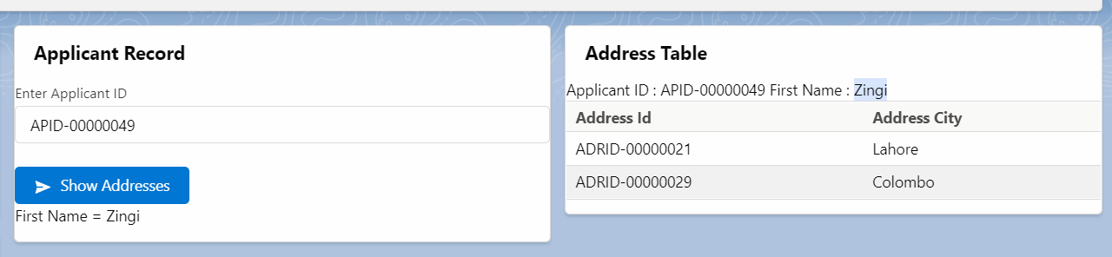





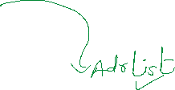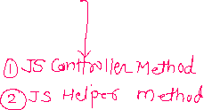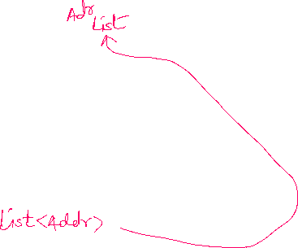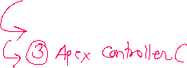

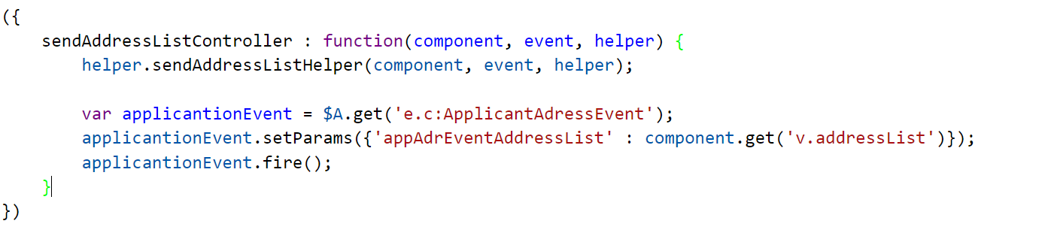

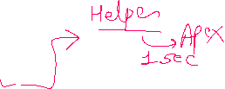

2]

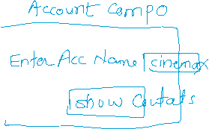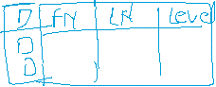

Show Address Records + Show Passport Records at the same time.

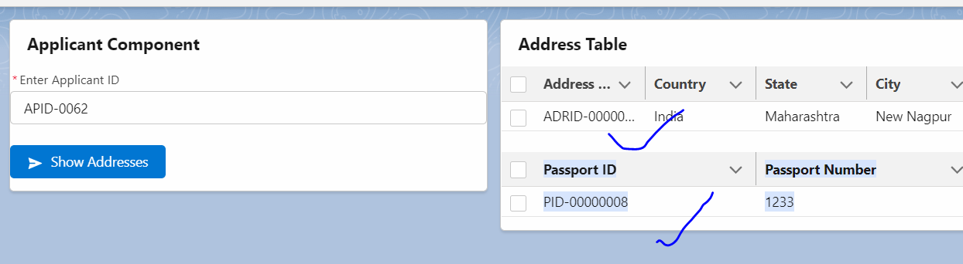

HINT:

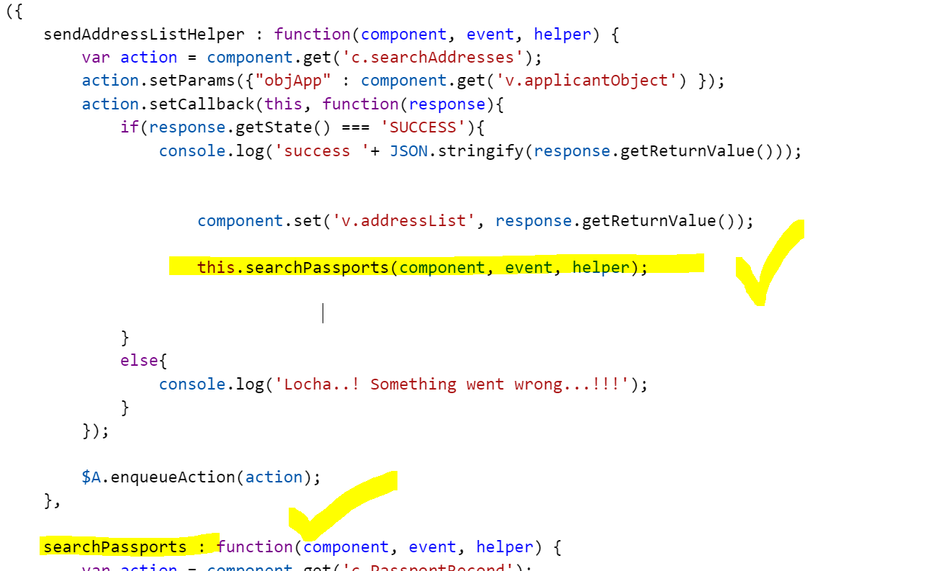

1] Spinner, Button Icon, Combo Box

2] Toast Message

<https://www.biswajeetsamal.com/blog/display-toast-message-in-lighting-component/>

3] Table Handling